BIOLOGY CELL CYCLE UNIT GUIDE ANSWERS

A. Chapter 5.1
1. The cell cycle has four main stages – G1, S, G2, and M. What occurs in the cell during each stage?
G1 = cell grows (produces cell membrane, cytoplasm, and organelles)
S = DNA replication
G2 = cell continues growing and prepares for division.
M = cell divides

2. Predict which stages of the cell cycle generally require about the same amount of time in all human
cells?
S phase (DNA replication)

3. State the relationship between a cell’s surface area and its volume.
Smaller cells have a larger surface area to volume ratio. As a cell grows, they both increase.
However, the surface area does not increase as quick as the volume so that ratio decreases.

4. Which has the larger ratio of surface are to volume, a tennis ball or a soccer ball? Explain.
A tennis ball. Because the volume increases much faster than the surface area.

B. Chapter 5.2
1. Describe the relationship between a molecule of DNA and a chromosome.
Chromosomes are made of DNA wrapped around histone proteins. Thus chromosomes contain
DNA.

2. Draw what a chromosome looks like during metaphase. Identify the chromatids and the centromere.
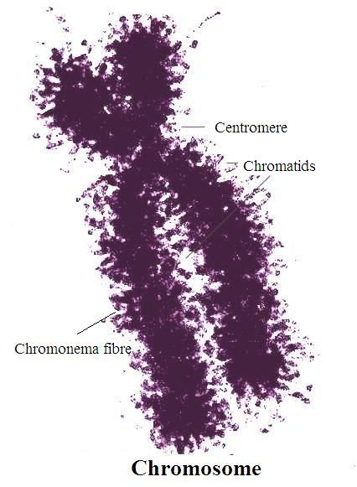
3. Briefly explain why the daughter cells resulting from mitosis are genetically identical to each other
and to the original cell.
The purpose of mitosis is to make identical copies of cells for growth, repair, or replacement. The
cells are identical because the DNA is copied during the S phase before cell division and then each
resulting cell gets a matching copy of the chromosomes.

4. Compare cytokinesis in animal versus plant cells.
Cytokinesis in animal cells results in two difference cells as the cytoplasm pinches off the
membrane. In plants, there are cell walls. Because of this, a cell plate develops in between the two
new nuclei, thus separating the cells.

C. Chapter 5.3
1. Describe what a growth factor is and how it influences the cell cycle.
Growth factors are chemicals released by cells to tell other cells to divide. They are released when
it is necessary for mitosis to happen.

2. Explain how cancer cells differ from normal cells.
Cancer cells begin as normal cells. However, something occurs in them that causes them to ignore
the checkpoints of the cell cycle. Thus they continue divide rapidly without the usual checking.

3. Compare benign and malignant tumors.
Benign tumors are isolated to one place in or on the body. Malignant tumors spread to other
areas.

D. Chapter 6.1
1. State the location of germ cells in the human body.
Germ cells are located in the testes in males and ovaries in females.

2. Differentiate between an autosome and a sex chromosome.
Autosomes are the first 22 pairs of chromosomes. They contain genes that are not used to
determine the gender of the organisms. Sex chromosomes are the 23rd pair of chromosomes.
They contain genes that determine gender.

3. Is the cell that results from fertilization a haploid or diploid cell? Explain.
It is diploid. Fertilization involves two haploid cells joining together to form a zygote. For
example, a sperm has 23 chromosomes and so does an egg. When they combine, the resulting cell
is diploid.

4. A fruit fly has diploid cells with 8 chromosomes. Explain how many chromosomes are in its haploid
gametes.
The gametes would have a total of 4 chromosomes. The eight chromosomes in the diploid cells
include homologous pairs. During meiosis, the homologous pairs are separated from each other
so that the gametes only possess half of the chromosomes.

5. Does mitosis or meiosis occur more frequently in your body? Explain your answer.
Mitosis occurs more frequently because it is used for repair and replacement as well as growing.
Meiosis only produces gametes.

E. Chapter 6.2
1. How do homologous chromosomes differ from sister chromatids?
Homologous chromosomes are chromosomes inherited from each parent. They have the same
genes in the same order. However, they may differ in the actual trait. For instance, they both have the gene for hair color. But the one you got from your dad may code for brown hair while the one you got from your mom may code for blonde hair. Sister chromatids are exact copies of each other. They are what is created during DNA replication.
2. List the key differences between meiosis 1 and meiosis 2.
Meiosis I involves the separation of homologous pairs. Meiosis II is the separation of sister
chromatids.

F. Chapter 8.7
1. Describe three ways mutations can occur.
1. Point (substitution) – one nucleotide is substituted for another.
2. Insertion – an extra nucleotide is inserted into a strand of DNA.
3. Deletion – a nucleotide is removed from a strand of DNA.

2. Explain why frameshift mutations have a great effect than do point mutations.
Frameshift mutations (insertion or deletion) have a greater effect because they affect a larger
number of amino acids. If a frameshift mutation occurs at the beginning of a strand of DNA, all of the codons that follow will be changed. A point is typically just one codon affected.

3. If GUA is changed to GUU, will the resulting protein be affected? Explain.
Not necessarily. It depends on if the two codons code for the same amino acid or not. Often the last nitrogen base will not affect the amino acid it codes for.

Multiple Choice
1. B
2. D
3. B
4. D
5. B

