(B.5) Science concepts: The student knows how an organism grows and the importance of cell differentiation. The student is expected to:
- (5A) Describe the stages of the cell cycle, including deoxyribonucleic acid (DNA) replication and mitosis, and the importance of the cell cycle to the growth of organisms; Readiness Standard
- (5C) Describe the roles of DNA, ribonucleic acid (RNA), and environmental factors in cell differentiation; Supporting standard
- (5D) Recognize that disruptions of the cell cycle lead to diseases such as cancer. – Supporting standard
(B.6) Science concepts: The student knows the mechanisms of genetics, including the role of nucleic acids and the principles of Mendelian Genetics. The student is expected to
- (6E) Identify and illustrate changes in DNA and evaluate the significance of these changes; Readiness Standard
- (6G) Recognize the significance of meiosis to sexual reproduction - Supporting standard

- Why do cells divide?

- Fill in the following tables showing you understand the two types of cell divisions:

What are the two types of cell divisions?
What is the purpose of each type of cell division?

How many and what type of cells are produced from each type of cell division?

- Label the cell cycles below showing you understand the events that occur in each.
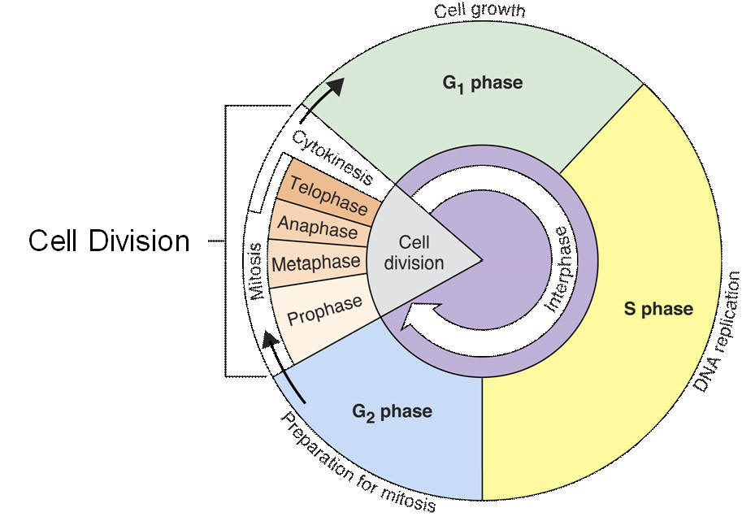

- Cells spend most of their time in which part of the cell cycle?
- What happens during the S-phase?
- What happens during G₁ and G₂?
- What happens in G₀?
- G₁, S, and G₂ are collectively called?
- What happens during the M-phase?
- List in order, the phases of mitosis (M-phase)

- After the M-phase, cells go through cytokinesis; what does this mean?

- What occurs during DNA replication? Why does this have to occur before the nuclear contents or chromosomes are divided in mitosis?

- Why is the cell cycle important to the growth of organisms?

- When the cell cycle doesn’t proceed as it should, uncontrolled cell division can occur and diseases, such as _____________________ result.

- What is the significance of meiosis to sexual reproduction? (In terms of chromosome number and in terms of variation)

- What event is this? When does it occur? Why is it important?
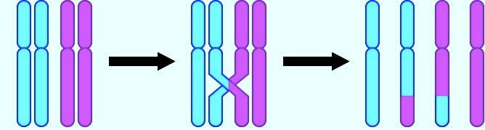

- What is independent assortment? When does it occur? Why is it important?

- A sudden genetic change is known as a(n) ____________________________ and it can be _________________________, beneficial, or have no effect.

- When homologous chromosomes fail to separate correctly during anaphase-I or if chromatids fail to separate correctly during anaphase-II, ______________________________occurs. An example of this could be ________________________________________

- After an egg is fertilized by a sperm cell, what is produced? Is this cell diploid or haploid? 2n or n?

- What is a karyotype and what can you tell from it?

- Identify the types of chromosomal mutations shown.
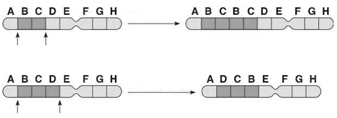

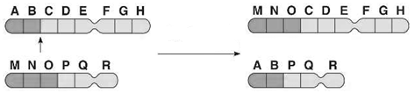

- Check which type of cell division best describes the following? (You can check both if you need to)
 | Mitosis | Meiosis
Produces identical daughter cells
Diploid to haploid

Produces gametes

46 chromosomes 23 chromosomes
8 chromosomes 8 chromosomes
Replication occurs

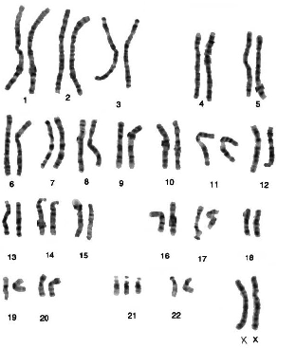
- Is this a normal karyotype
Explain.

