(B.5) Science concepts: The student knows how an organism grows and the importance of cell differentiation. The student is expected to:
- (5A) Describe the stages of the cell cycle, including deoxyribonucleic acid (DNA) replication and mitosis, and the importance of the cell cycle to the growth of organisms; Readiness Standard
- (5C) Describe the roles of DNA, ribonucleic acid (RNA), and environmental factors in cell differentiation; Supporting standard
- (5D) Recognize that disruptions of the cell cycle lead to diseases such as cancer. – Supporting standard
(B.6) Science concepts: The student knows the mechanisms of genetics, including the role of nucleic acids and the principles of Mendelian Genetics. The student is expected to
- (6E) Identify and illustrate changes in DNA and evaluate the significance of these changes; Readiness Standard
- (6G) Recognize the significance of meiosis to sexual reproduction - Supporting standard

- Why do cells divide? To increase their surface area (cell membrane) to volume (cytoplasm) ratio (so there is more cell membrane for osmosis, diffusion, active transport, etc.)

- Fill in the following tables showing you understand the two types of cell divisions:

What are the two types of cell divisions? | Mitosis | Meiosis
What is the purpose of each type of cell division? | Produce daughter cells that are identical to each other and to the parent cell | Produce gametes (with half the chromosome #) that are different from each other
How many and what type of cells are produced from each type of cell division? | 2 daughter cells are produces – they are somatic (body) cells | 4 gametes are produced

- Label the cell cycles below showing you understand the events that occur in each.
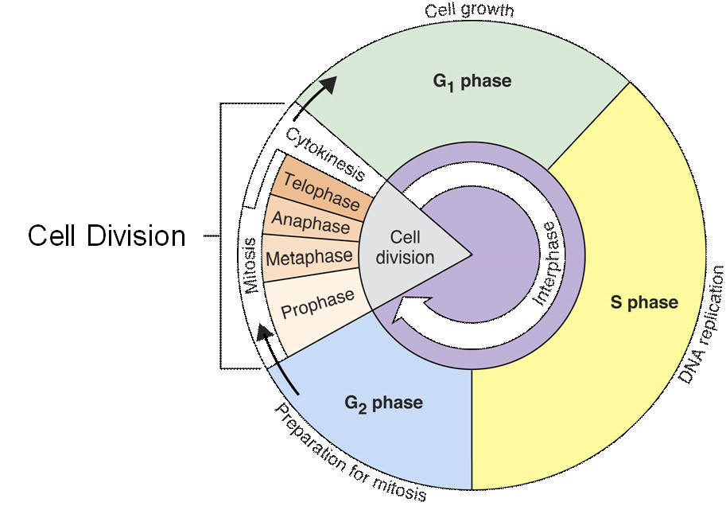

- Cells spend most of their time in which part of the cell cycle? Interphase
- What happens during the S-phase? DNA replicates
- What happens during G₁ and G₂? Cell grows and gets ready for cell division
- What happens in G₀? Cell leaves the cell cycle and will not divide
- G₁, S, and G₂ are collectively called? interphase
- What happens during the M-phase? Chromosomes or nuclear contents (DNA) divides
- List in order, the phases of mitosis (M-phase) prophase – metaphase – anaphase – telophase (followed by cytokinesis) – be able to do this by picture as well

- After the M-phase, cells go through cytokinesis; what does this mean? Cytoplasm divides

- What occurs during DNA replication? DNA makes an exact replica or copy of itself. Why does this have to occur before the nuclear contents or chromosomes are divided in mitosis? There have to be 2 copies of the genetic instructions so that when the cell divides that both new daughter cells have a complete set of genetic instructions.

- Why is the cell cycle important to the growth of organisms? Without it multicellular organisms couldn’t make more cells, repair cells, or grow

- What is the purpose of the check points in the cell cycle? Detects problems with DNA, tries to repair the problems or damage – if not terminates the cell; this ensures chromsosomes are intact and the each stage of the cell cycle is completed before the following stage is initiated

- When the cell cycle doesn’t proceed as it should, uncontrolled cell division can occur and diseases, such as CANCER result.
- What regulates the cell cycle? enzymes and other regulatory proteins
- What is the significance of meiosis to sexual reproduction? (In terms of chromosome number and in terms of variation) reduces the chromosome number by half (so that after fertilization the zygote has the correct number of chromosomes) and produces variation in gametes – so that there will be variation in future offspring

- What event is this? Crossing over When does it occur? Prophase I of meiosis Why is it important? Provides variation
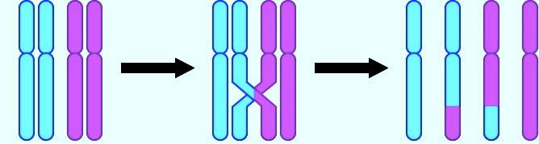

- What is independent assortment? How the chromosomes line up in metaphase-I & II (meiosis) (When does it occur? Why is it important? Increases variation
- A sudden genetic change is known as a(n) mutation and it can be harmful, beneficial, or have no effect.
- When homologous chromosomes fail to separate correctly during anaphase-I or if chromatids fail to separate correctly during anaphase-II, nondisjunction occurs. An example of this could be Down’s Syndrome (Trisomy 21) – there could be other examples given
- What is the significance of a mutation if it occurs in a somatic cell? Can cause cancer or an illness in the individual
- What is the significance of a mutation if it occurs in a germ cell or gamete? Can cause cancer or an illness in the offspring of the individual
- When would a point (gene) mutation least likely affect a cell? When the nucleotide is the 3rd position (& will code for the same amino acid)

- After an egg is fertilized by a sperm cell, what is produced? zygote Is this cell diploid or haploid? diploid 2n or n? 2n
- Variation is the raw material for natural selection. What are sources of variation?
Mutation (spontaneous cause); crossing over, independent assortment, random recombination

- As this cell divides multiple times, the daughter cells will become more and more differentiated. What does this mean? When one cell changes into another cell type - cells will become more and more specialized to do only a specific job

- What is a karyotype and what can you tell from it? Picture of an individual’s chromosomes arranged in homologous pairs. You can tell if the sex of the individual, if they have the correct number of chromosomes, and if they have extra or missing pieces of chromosomes.

- Fertilization of (n) gametes restores what chromosome number? Diploid (2n) or original chromosome number
.

- Identify the types of chromosomal mutations shown.
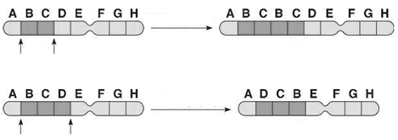
inversion
duplication

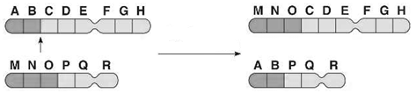
deletion
translocation

- Check which type of cell division best describes the following? (You can check both if you need to)
 | Mitosis | Meiosis
2n 2n | √
Produces identical daughter cells | √
Diploid to haploid |  | √
Produces gametes |  | √
46 chromosomes 23 chromosomes |  | √
8 chromosomes 8 chromosomes | √
Replication occurs | √ | √
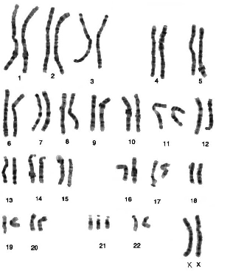
- Is this a normal karyotype? No Explain. There are 3 copies of the 21st chromosome

