Cell Theory Scientists
You are a member of the Nobel Prize Committee. As a member you must decide which scientist is most worthy of the Nobel Prize. It is your job to research the nominated scientists listed below and decide which one is most deserving of this year's most prestigious award. Each of these scientists has contributed in the development of the cell theory in some way.
A-Research
Scientist | Born | Death | Country | Contribution to the cell theory | Education | Other info
Zacharias Jansen

Robert Hooke

Anton Van Leeuvenhoek

Matthias Schleiden

Theodor Schwann

Rudolph Virchow

B-Nobel Prize Award

_______________________________________________________
Name of Scientist

Winning Category:
_______________________________________________________
Nobel Prize Winner

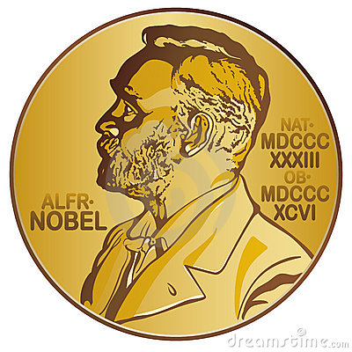

C-Reasons for award
In at least 5 sentences, explain why you chose your scientist for the Nobel Prize Award.
______________________________________________________________________________________________________________________________________________________________________________________________________________________________________________________________________________________________________________________________________________________________________________________________________________________________________________________________________________________________________________________________________________________________________________________________________________________________________________________________________________________________________________________________________________________________________________________________________________________________________
______________________________________________________________________________________________________________________________________________________________________________________________________________________________________________________________________________________________________________________________________________________________________________________________________________________________________________________________________________________________________________________________________________________________________________________________________________________________________________________________________________________________________________________________________________________________________________________________________________________________________

