NAME: _________________________________________________

ECOLOGY AND BEHAVIOR TEST
2014-15

1. When homeowners in Allen mow their lawns, they often collect clippings and bag them up, leaving them out at
the curb to be picked up on trash collection days. Your keen environmental awareness empowers you to
approach the city council to propose a city ordinance prohibiting this practice. The council asks that you propose
a potential solution to this problem. Which of the actions below would provide the greatest benefit for the local
suburban ecosystem?
(A) Allow sheep to graze the lawn and then collect the sheep's feces to be delivered to the landfill.
(B) Collect the clippings and wash them into the nearest storm sewer that feeds into the local lake.
(C) Collect the lawn clippings and burn them.
(D) Collect the lawn clippings and add them to a compost pile, don't collect the clippings and let them
decompose into the lawn, or apply composted clippings to the lawn.

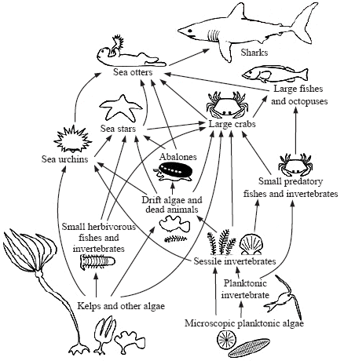

2. What will happen to the sizes of the populations in the food web above if the sea otter disappears?
(A) Sea stars decrease and sharks increase. (C) Large fish increase and sea urchins decrease.
(B) Abalones increase and sharks increase. (D) Sea urchins increase and kelps decrease.

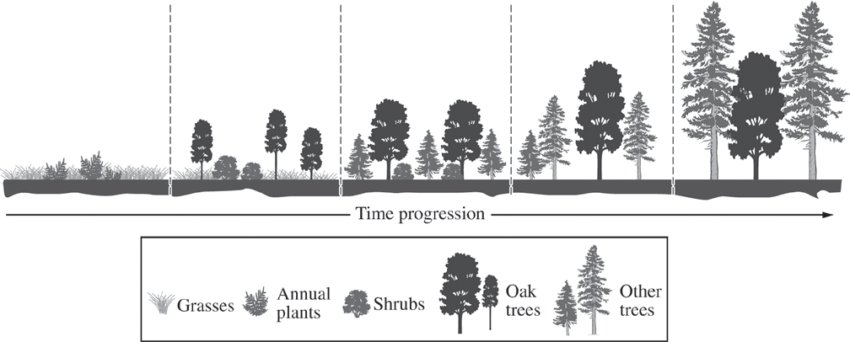

3. The diagram above shows the progression of ecological events after a fire in a particular ecosystem. Based on
the diagram, which of the following best explains why the oak trees are later replaced by other trees?
(A) Oak trees succumb to environmental pollutants more readily than do either the shrubs or the other trees.
(B) Eventually the other trees grow taller than the oak trees and form a dense canopy that shades the
understory.
(C) Roots of shrubs proliferate in the soil of the forest and prevent the oak trees from obtaining water.
(D) Oak trees alter the pH of the soil, making the forest better suited for shrubs and other trees.
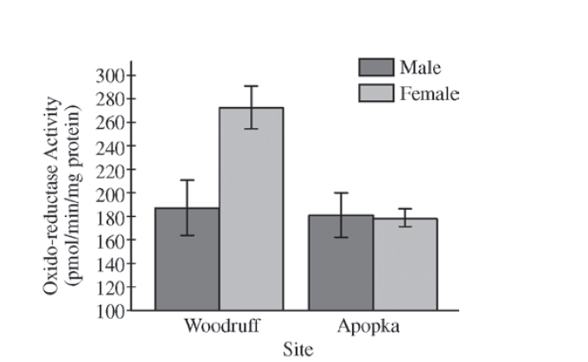
Testosterone oxido-reductase is a liver enzyme that regulates testosterone levels in alligators. One study compared testosterone oxido-reductase activity between male and female alligators from Lake Woodruff, a relatively pristine environment, and from Lake Apopka, an area that has suffered severe contamination. The graph above depicts the findings of that study.

4. The data in the graph best support which of the following claims?
(A) Environmental contamination elevates total testosterone oxido-reductase activity in males.
(B) Environmental contamination elevates total testosterone oxido-reductase activity in females.
(C) Environmental contamination reduces total testosterone oxido-reductase activity in males.
(D) Environmental contamination reduces total testosterone oxido-reductase activity in females.

5. In the Blackland Prairie ecosystem, squirrels make up a large portion of the diet of coyotes. A viral disease in the
squirrel population begins to reduce their population over a period of months. Which graph best represents the
expected changes in population size of the coyotes and the squirrels?
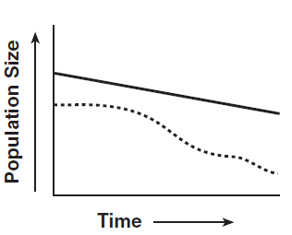
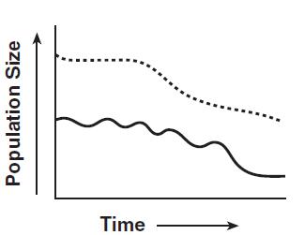
(A)
(C)

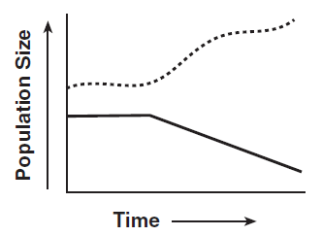
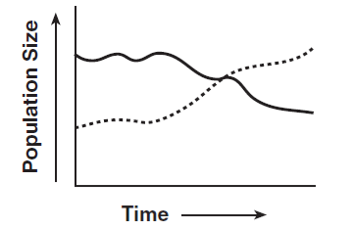
(D)
(B)

- The Piney Woods of eastern Texas is home to a wide variety of organisms ranging from the grass Longleaf Oats to coyotes. Which of the following best explains why these varied species can live together in this particular ecosystem?
(A) Each species functions at a different trophic level.
(B) Each species occupies a different niche.
(C) Each species inhabits a different biome.
(D) Each species lives in a slightly different habitat.
- A population of mockingbirds has an annual per capita birth rate of 0.07 and an annual per capita death rate of 0.04. Calculate an estimate of the population change for a population of 1,000 birds in one year.

(A) An increase of 30 birds
(B) An increase of 300 birds
(C) A decrease of 300 birds
(D) A decrease of 30 birds

8. Population growth, as shown by the curve below, is the result of changes in mortality, natality,
immigration and emigration. Which of the following statements about population growth is correct?
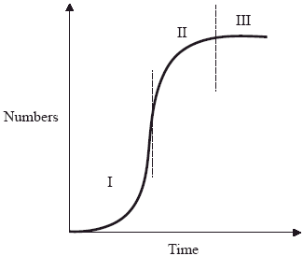
(A) In phase II mortality and emigration are less than natality and immigration.
(B) In phase I there is no mortality.
(C) In phase III mortality and emigration are less than natality and immigration.
(D) In phase II mortality equals natality and immigration equals emigration.

A group of students wanted to study the impact that two species had on one another if they shared the same
habitat. They cultured two different species of the protist Paramecium in three different petri dishes over a
period of 72 hours and recorded their data. The graph below illustrates their results.

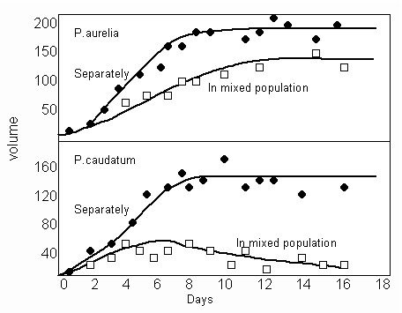
9. Which of the following best describes the relationship between these two species of Paramecium grown in
mixed culture?
(A) P. caudatum probably used available food supplies more efficiently than P. aurelia
(B) P. caudatum and P. aurelia probably occupy the same niche
(C) P. aurelia benefits by being grown in a mixed culture
(D) P. caudatum is more successful than P. aurelia in mixed culture

10. How does natural selection influence the development of altruistic behaviors?
(A) Animals that perform altruistic acts are allowed by their population to breed more, thereby passing on
their behavior genes to future generations.
(B) By his/her actions, the altruist increases the likelihood that some of its genes will be passed on to the
next generation.
(C) Altruistic behaviors lower stress in populations, which increases the survivability of all the members of
the population.
(D) The altruist is appreciated by other members of the population because their survivability has been
enhanced by virtue of his/her risky behavior.

The accidental introduction of invasive species of plants and animals often causes severe problems in the ecosystem where they are introduced. One such example in Texas is the Rasberry crazy ant (Nylanderia sp. near pubens), which is thought to have arrived in Harris County during 2002 from South America. This ant species is known to attack livestock, displace already existing species (including other ant species such as red fire ants) and has damaged electrical equipment in human habitations. N. pubens consumes “honeydew,” a sugary liquid substance secreted as a waste product by aphids, which suck the sap out of plants.
11. Which of the following statements best explains the impact that N. pubens has on its environment?
(A) N. pubens is a keystone species in its new environment.
(B) N. pubens does not directly compete with other species in this environment.
(C) N. pubens has found a place within the existing food web in its new environment.
(D) N. pubens disrupts existing mutualistic relationships.

The diagram below shows part of the carbon cycle.
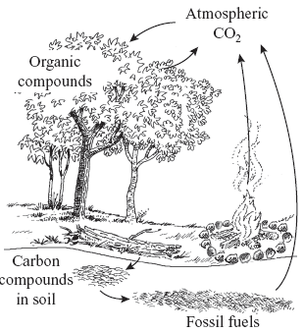

12. Suppose that the forest shown above was clear-cut to harvest the trees for paper production. What is the
most immediate effect on the carbon cycle in that forest?
(A) increased production of organic compounds
(B) increased rates of decomposition
(C) decreased combustion of fossil fuels
(D) decreased use of atmospheric CO2

The graph below shows variation in the concentration of CO2 in the atmosphere as measured at Mauna Loa in Hawai’i. The small inset graph shows the variations in CO2 during a one- year period.
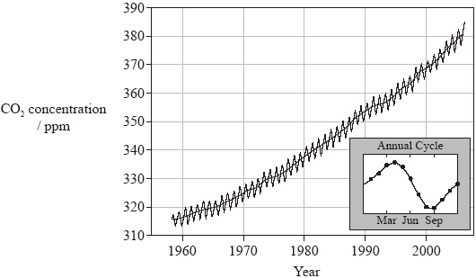

13. Which of the following statements explains why the amount of CO2 falls between April and August?
  - (A) There is a seasonal increase in the amount of CO2 dissolved in the oceans.
  - (B) There is a seasonal increase in the rate of photosynthesis in the northern hemisphere forests.
  - (C) There is a seasonal decrease in the rate of fossil fuel consumption.
  - (D) There is a seasonal decrease in the rate of photosynthesis in the northern hemisphere forests.

14. Prairie dogs once covered the expanses of the Great Plains. Their grazing made the grass more nutritious
for the huge herds of bison, and they were preyed upon by a variety of snakes, raptors, and mammals. In
fact, the black-footed ferret (now endangered) specialized in prairie dog predation. Today, increases in
housing and agricultural developments have eradicated many prairie dog towns. Which of the following
statements about prairie dogs is true?
(A) Their fundamental niche has expanded.
(B) Their realized niche has expanded.
(C) They have a competitive relationship with bison.
(D) Their fundamental niche has been compromised.

- Populations of Caribbean coral have decreased by nearly 80 percent over the past 30 years due to brown
band disease caused by a group of protists called ciliates. Which of the following is most likely a major factor
leading to the increased amount of brown band disease in the coral?
  - (A) Water temperatures have increased and favored the growth of harmful ciliate populations.
  - (B) Levels of spawning have decreased and lowered reproductive rates.
  - (C) Symbiotic algae are living in the coral cells.
  - (D) Several different species of fish live on the coral reefs.

- A population of armadillos inhabits a vacant field across the street from your neighborhood elementary school. Which of the following activities in the ecological community surrounding the armadillo habitat will decrease K for this population?
- Abundant rainfall during the spring has stimulated the growth of grasses which harbor beetles, whose
larvae the armadillos eat.
- A community organization decides to build a community garden on the field using plants that harbor
beetles.
- The city’s parks and recreation department purchases the land and reserves it as a regional nature
preserve.
(D) A real estate developer purchases land next to the vacant lot and builds a strip shopping center on it.

Use the graph below to answer question 17.

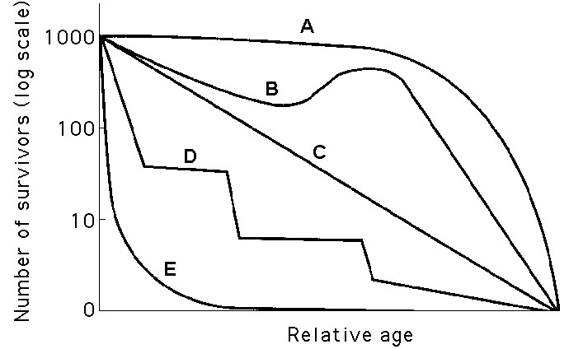

17. Which statement best explains survivorship curve A?
(A) This curve is likely of a species that produces few offspring, most of which survive to middle age.
(B) It is likely a species that provides little postnatal care, but lots of care for offspring during midlife as
indicated by increased survivorship.
(C) This curve is likely of a species that produces lots of offspring, only a few of which are expected to
survive.
(D) It is likely a species where no individuals in the cohort die when they are at 60—70% relative age.

- Which organism is most likely not functioning as a keystone species in its ecosystem?
- A population of zebra mussels that compete with native species, reducing the biodiversity of the Great
Lakes ecosystem
- An elephant that destroys trees, making room for grass species and preventing the environment from
becoming a woodland
- A beaver that transforms its territory from a stream to a pond or swamp, maintaining the habitat for a
variety of native species
- A group of black-tailed prairie dogs whose burrows act as homes to other creatures, including
burrowing owls, badgers, rabbits, snakes, salamanders, and insects

19. You are told that the song of males among a particular songbird species has an innate component but is
also largely learned. Nestling males imprint on their father's song and then sing it themselves when they
reach sexual maturity. Which of the following observations would lead you to doubt this information?
- A male chick reared in isolation but introduced as an older juvenile into an aviary containing normal
males of his species sings his species' song.
- A male chick who is reared in isolation but hears tape recordings of his species' song grows up to sing
normally.
- A male chick who is reared in isolation but hears tape recordings of a different species' song grows up to
sing that species' song.
D) A male chick fostered in the nest of a different species grows up to sing the song of its foster species.

20. A hypothetical community on a barren mid-Atlantic island consists of two fish-eating seabirds (the booby
and the noddy), the fungi and microorganisms that live on the birds' dung, a tick that feeds on these two
birds, a cactus, a moth that feeds on cast-off feathers, a beetle that lives on dung organisms, and spiders that
eat the other arthropods. There are no other plants and no lichens. Which of the following choices
incorrectly pairs a member of this assemblage with its position in the trophic structure?

A) fungi, detritivores
B) booby, primary consumer
C) moth, detritivore
D) cactus, producer

21. Which of the following options correctly pairs a biome and its characteristics?
A) temperate broadleaf forest=mild winters, moderate rainfall, predominantly dicot vegetation
B) chaparral=mild, rainy winters; long, hot, but wet summers
C) savanna=long, cold winters, vegetation dominated by conifers
D) tundra=very cold winters; only the upper layer of the soil thaws during summer

22. An insectivorous bird has the choice of eating (1) meadow beetles, which are abundant and large but expose
the bird to hawk predation; (2) under-a-rock beetles, which are large and fatty but hard to obtain; and (3)
under-a-leaf beetles, which are easy to obtain but small. The bird has nestlings to feed. As an optimal
forager, it will
A) concentrate on under-a-leaf beetles because they are easy and safe.
B) concentrate on under-a-rock beetles because they are energy-rich.
C) eat one kind of beetle at a time (first under-a-leaf, then meadow, then under-a-rock), switching to a new
kind when the old kind becomes scarce.
D) eat all three kinds of beetles, balancing the energy spent and the risks incurred against the energy gained.

23. Denitrifying bacteria convert ________ to ________.

A) ammonium . . . nitrates
B) nitrates . . . nitrogen gas
C) nitrogen gas . . . nitrates
D) nitrogen gas . . . nitrites

24. About how much of the energy in the producers of an ecosystem will be available to secondary
consumers in this ecosystem?

A) 100%
B) about 50%
C) about 10%
D) about 1%

25. Which of the following situations could represent kin selection in action?
A) You help your friend with linguistics, and your friend helps you with biology.
B) You help your brother pay for his children's college tuition, even though he may not be able to pay
you back.
C) When your mother gets old, you help her pay her property taxes.
D) You inexplicably forget to use birth control, and a child results.

