NAME: _________________________________________________________________

ENZYME WORKSHEET

Sucrose is a sweetener found in many candies. It is a carbohydrate disaccharide made up of glucose and
another sugar called fructose. When we eat sucrose, it must be digested or broken down into smaller
substances, which our cells can absorb. An enzyme (protein) called sucrase speeds up this chemical reaction by breaking the chemical bond in sucrose, the substrate. High heat and strong acids or bases destroy the enzyme and would stop the chemical reaction. The only way to make the reaction go faster is to add more enzymes. Scientists support the “lock and key” model below for how an enzyme speeds up chemical reactions. The letters “ase” at the end of words help us identify enzymes.
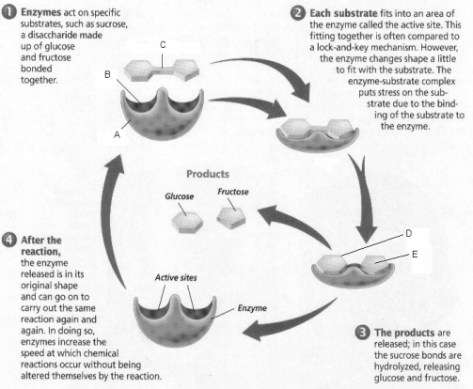

1. Label A-E directly on the picture above: active site, substrate, enzyme, glucose and fructose

2. What is the substrate in the picture above?

3. What is the name of the enzyme?

4. What 3 letters in the enzyme’s name tells that it is an enzyme?

5. How can you tell from the diagram that sucrase is not used up during the chemical reaction?

I can tell that sucrase is not used up during the reaction because __________________________________________________.
6. What type of proteins speed up a chemical reaction?

7. How are enzymes destroyed?

Enzymes can be destroyed by ________________________________________________________________________________________.____

pH AND ENZYME ACTIVITY

Experiments were designed to study the effect of pH on the rate of enzyme action for 2 different enzymes found in animals, Enzyme A and Enzyme B. Enzyme A is found in the stomach and digests meats. Enzyme B is found in the intestine and digests facts. Use the graph to answer the following questions.
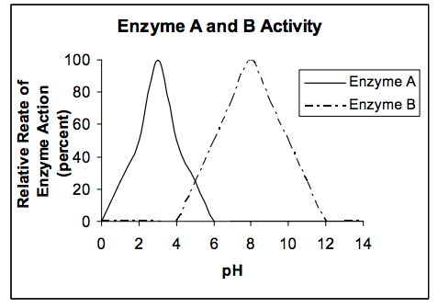

- At what pH is Enzyme A working at its maximum rate?

- Since Enzyme A is found in the stomach, what is the probable pH of the stomach?

- At what pHs does Enzyme A not work?

- At what pH is Enzyme B working at its maximum rate?

- Since Enzyme B is found in the intestine, what is the probable pH of the intestine?

- If Enzyme A were produced in the intestine, would this enzyme still carry out its usual function of digestion? Explain.

If enzyme A were produced in the intestine it would / would not still carry out its usual function because

_________________________________________________________________________________________________________.

