Name___________________________________________

Homeostasis and Exercise

Background: Your body's temperature, heart rate, and blood pressure need to remain within certain set ranges. In this lab, you will work in groups to examine the effects of exercise on the circulatory and respiratory systems, and on perspiration level. You will then observe how the body reacts when exercise is stopped.

Problem: How does exercise affect a person's heart rate, breathing rate, and perspiration level?

Hypothesis: Write a hypothesis about the effect of exercise on the dependent variables that you are measuring, giving a possible explanation to the problem listed above.

Procedure:
- Choose one volunteer to complete jumping ‐‐ jacks at a pace that can be maintained for eight minutes (just choose right now; don’t actually do the activity yet).

- Make sure the volunteer is inactive for a few minutes before the experiment begins.

- Measure the heart rate by taking his or her pulse; you can do this one of two ways.
  - Radial Pulse: This is probably what we're most familiar with when visiting the doctor's office. Take two fingers, preferably the 2nd and 3rd finger, and place them in the groove in the wrist that lies beneath the thumb. Move your fingers back and forth gently until you can feel a slight pulsation ‐ this is the pulse of the radial artery, which delivers blood to the hand. Don't press too hard, or else you'll just feel the blood flowing through your fingers!
  - Carotid Pulse: The carotid arteries supply blood to the head and neck. You can feel the pulse of the common carotid artery by taking the same two fingers and running them alongside the outer edge of your trachea (windpipe). This pulse may be easier to find than the radial artery. Since the carotid arteries supply a lot of the blood to the brain, it's important not to press on both of them at the same time!

- Count the number of beats in 15 seconds. Your partner will use the clock or stopwatch to tell you when to start and when to stop.

- Multiply the number of beats in 15 seconds by 4 to calculate the beats per minute. Record the data in the Table 1 under the 0 minutes box.

- Measure the person's breathing rate by counting the number of breaths taken in 15 seconds. The multiply this number by 4 to calculate breaths per minute. Add this information to the table.

- Rate the person's perspiration level from 1 to 5 (1 = none; 5 = droplets dripping down the face). Note this observation in the table.

- Have the volunteer do jumping jacks for 2 minutes. Caution: If the person exercising feels discomfort at any time, stop the experiment and inform your teacher.

- After 2 minutes, measure heart rate, breathing rate, and perspiration level, and record the data.

- Measure the pulse, breathing and perspiration levels as quickly as you can so that the volunteer can resume exercise. Do not have volunteer wait while you do the calculations and enter the data.

- Repeat three more times and record your data at each point.

- After the final recording of the dependent variables, wait 1 minute and 30 seconds with the volunteer at rest. Then measure all of the variables again. Record this data under the “9.5 Time (min.) box”.

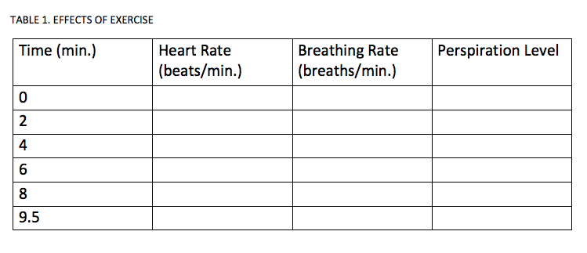
Analyze and Conclude:

1. What is the independent variable in this experiment?

2. Graph the relationship between the independent and dependent variables. You may choose one graph to
display all of your data, or you may use separate graphs for each of the dependent variables.

Explain your graph choice (Why did you choose this graph to show your data?).

What are the effects of exercise over time on the circulatory and respiratory systems? On perspiration level?

What other processes could you have measured to determine the external and internal effects of exercise on the body?

How is perspiration level related to body temperature? How is perspiration related to homeostasis?

