MACROMOLECULE LAB: Lipid Test

Safety Procedures: GOGGLES MUST BE WORN FOR THE ENTIRE LAB PERIOD

1. Obtain five test tubes. Label each one of the following: water, vegetable oil, gelatin, starch, and glucose
2. Use a graduated cylinder to transfer 5 mL of water into the test tube labeled “distilled water.”
3. Repeat step 2 with each of the solutions (Each test tube should have only one item in it.)
4. Add 5 drops of Sudan III stain to each test tube.
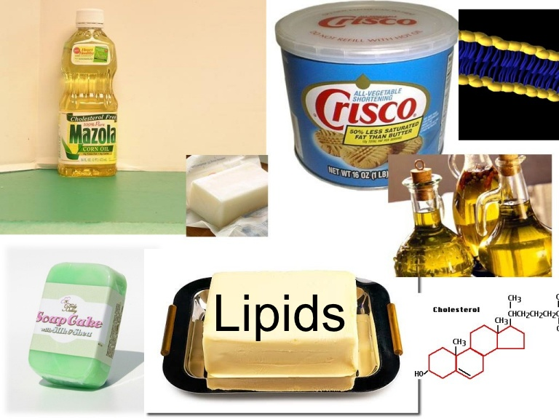
5. Gently shake the contents of each test tube. CAUTION: Use extreme care when handling Sudan III to avoid staining hands or clothing.
6. Sudan III will dissolve in lipids and stain them red.
In the Data Table, write a “+” if lipids are present
or a “-“ if lipids are not present.
7. Record a description of the contents of the test tubes.
8. Wash the test tubes thoroughly.

MACROMOLECULE LAB: Protein Test

Safety Procedures: GOGGLES MUST BE WORN FOR THE ENTIRE LAB PERIOD

1. Obtain five test tubes. Label each one of the following: water, vegetable oil, gelatin, starch, and glucose
2. Use a graduated cylinder to transfer 5 mL of water into the test tube labeled “water.”
3. Repeat step 2 with each of the solutions. (Each test tube should have only one item in it.)
4. Add 5 drops of Biuret Reagent to each test tube.
5. Gently shake the contents of each test tube. CAUTION: Biuret Reagent contains a strong base.
If you splash any on yourself wash it off immediately with water. TELL THE TEACHER.
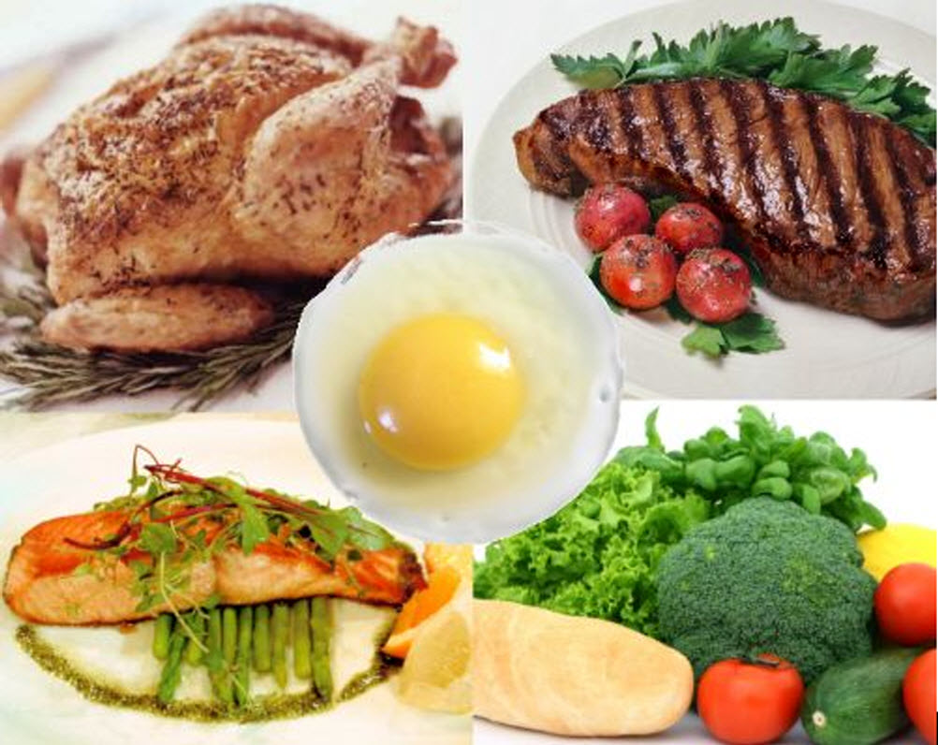
6. Biuret Reagent changes color from blue to violet in the presence of protein.
In the Data Table, write a “+” if protein is present
or a “-“ if protein is not present.
7. Record a description of the contents of the test tubes.
8. Wash the test tubes thoroughly.

MACROMOLECULE LAB: Complex Carbohydrate Test

Safety Procedures: GOGGLES MUST BE WORN FOR THE ENTIRE LAB PERIOD

1. Obtain five test tubes. Label each one of the following: water, vegetable oil, gelatin, starch, and glucose
2. Use a graduated cylinder to transfer 5 mL of water into the test tube labeled “water.”
3. Repeat step 2 with each of the solutions. (Each test tube should have only one item in it.)
4. Add 5 drops of Iodine to each test tube.
5. Gently shake the contents of each test tube.
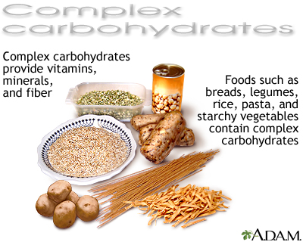
6. Iodine causes complex carbohydrates to turn dark blue or black. Substances without starch are colored brown by the iodine, but do not react with it.
In the Data Table, write a “+” if complex carbohydrates
are present or a “-“ if complex carbohydrates are not present.
7. Record a description of the contents of the test tubes.
8. Wash the test tubes thoroughly.
CAUTION: Use extreme care when handling Iodine
to avoid staining hands or clothing.

MACROMOLECULE LAB: Simple Carbohydrate Test

Safety Procedures: GOGGLES MUST BE WORN FOR THE ENTIRE LAB PERIOD

1. Obtain five test tubes. Label each one of the following: water, vegetable oil, gelatin, starch, and glucose
2. Use a graduated cylinder to transfer 5 mL of water into the test tube labeled “water.”
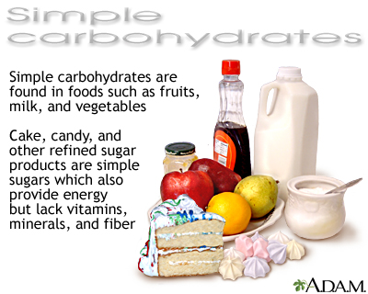
3. Repeat step 2 with each of the solutions (Each test tube should have only one item in it.)
4. Add 10 drops of Benedict’s Solution to each test tube.
5. Gently shake the contents of each test tube.
6. Place the test tubes in the hot water bath for 3-5 minutes.
Remove the test tubes using test tube holders.
7. A rusty brown color in response to Benedict’s Solution
indicates a large amount of simple sugars. An orange color
indicates a moderate amount and a green or yellow color indicates
a small amount of sugar. A blue color indicates no sugar present.
In the Data Table, write a “+” if simple carbohydrates are present or a “-“ if simple carbohydrates are not present.
8. Record a description of the contents of the test tube.
9. Allow the test tubes to cool and then wash them thoroughly.

NAME: __________________________________________________
MACROMOLECULE INTRODUCTION LAB

Objective: To test for the presence of macromolecules in various solutions.

Background
The most common macromolecules (organic compounds) found in living organisms are lipids, carbohydrates, proteins, and nucleic acids. Common foods, which often consist of plant materials or substances derived from animals, are also combinations of these macromolecules. Some of these compounds can be detected by taste, while others cannot. Therefore, scientists use certain tests to identify the presence of macromolecules.
Materials:

- Test Tubes and Rack
- Graduated Cylinder
- Hot Plate
- Benedict’s Solution
- Biuret Reagant
- Sudan IV Stain
- Iodine
- Gelatin solution

Procedures:

Follow the lab instructions found on each lab table then complete the chart on the back.

Inferences:
After completing the lab, explain why we use a water sample during each test.

Data Table: Presence (“+”) or Absence (“-“) of macromolecules in tested solutions. (The table also includes a description of the contents of each test tube)

SOLUTION | LIPIDS | PROTEINS | COMPLEX CARBOHYDRATES | SIMPLE CARBOHYDRATES
Water

Gelatin

Starch

Glucose

Vegetable Oil

NAME: __________________________________________________
MURDER AND A MEAL – THE CASE

A murder has occurred right here in our peaceful little town of Mansfield, TX. As top-notch biology students at Lake Ridge High School you have been asked to assist in the investigation of this most unfortunate incident. Central to identifying the individual who committed this crime is establishing where the victim was the day of the crime so that detectives can question the individuals with whom the victim came into contact. An autopsy was performed on the victim has revealed that the victim ate just prior to the time of death. Upon questioning the victim’s friends and family, detectives working the case have learned that the victim enjoyed eating at the following places.

Corky’s Brick Oven Pizzeria & Ristorante

The victim would never eat thin crust pizza from anywhere else! The victim would typically order a pizza with sausage, pepperoni, and bacon. List the macromolecules would you expect to find in the stomach contents of the victim if the victim’s final “pie” was eaten here.

Buffalo Wild Wings

The victim would hang out here to watch sporting events while feasting on
Blazin’ wings and celery. List the macromolecules would you expect to find in the stomach contents of the victim if the victim’s final “pie” was eaten here.

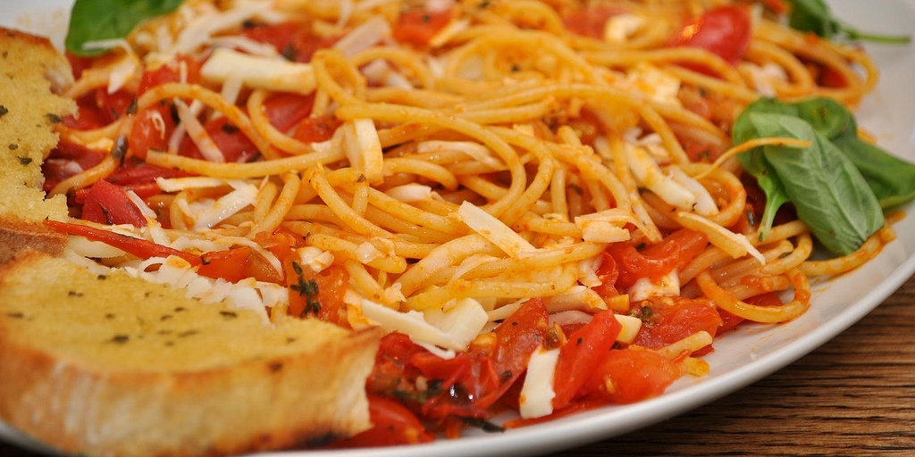
The Spaghetti Warehouse

The victim loved to go here for a night of bread, olive oil, and pasta. List the macromolecules would you expect to find in the stomach contents of the victim if the victim’s final “pie” was eaten here.

The forensic pathologist has removed the contents of the victim’s stomach for you to analyze in order to determine where the victim had his last meal.

Directions: Using the same methods practiced during the introductory lab, complete the table below for the sample you received from the pathologist.

SOLUTION | LIPIDS | PROTEINS | COMPLEX CARBOHYDRATES | SIMPLE CARBOHYDRATES
STOMACH CONTENTS

Conclusion Questions:

- Identify the restaurant the victim visited for his last meal.

The victim at his last meal at __________________________________________________.

- Provide a logical explanation, using data from the tests on the stomach contents, that explains
how you reached that conclusion.

I believe the victim ate his last meal at ___________________________________________ because __________________________________________________________________________________________________________________________________________________________________________________________________________________________________
Analysis Questions:

- You are getting prepared to take a “Man vs Wild” hike. Which restaurant would provide the best fuel for you to endure this long adventure? EXPLAIN. (Hint: which macromolecule is used for long term energy storage?)

The restaurant that would provide the best LONG TERM FUEL is ______________________________________ because_________________________________________________________________________________________________________________________________________________________________________________________________________________________

- People with diabetes are encouraged to stay away from foods that are rich in carbohydrates. How could your knowledge from this lab be used to decide whether a food should be served to a person with diabetes? (Hint: If you are unfamiliar with diabetes, refer to the short reading on the table).

A person with diabetes should avoid foods high in ____________________________________________. Therefore, I could use the data from this lab to tell a person with diabetes __________________________
_________________________________________________________________________________________________________________
_________________________________________________________________________________________________________________
- Sudan III turns red in the presence of lipids. A very thin slice is removed from a peanut and treated with Sudan III. Then a drop of Biuret Reagent is added to the peanut slice. When you examine the peanut slice under a microscope, patches of red and blue-violet are visible. What conclusions can you draw from your observation?

Because I can see patches of red and blue-violet, I would conclude peanuts contain both ____________________________________________ and ________________________________________.

NAME: __________________________________________________
MACROMOLECULES AND DIGESTION
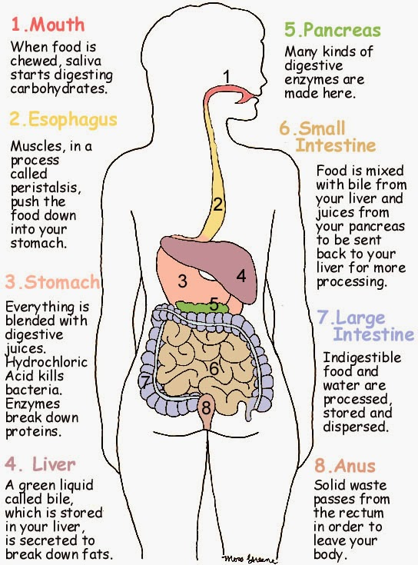

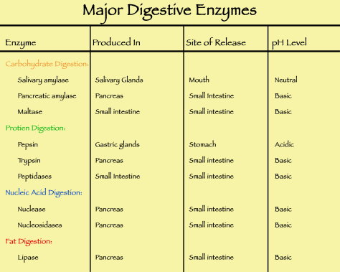

http://kidshealth.org/kid/cancer_center/HTBW/digestive_system.html

http://kidshealth.org/teen/your_body/body_basics/digestive_system.html

http://www.livestrong.com/article/465047-macromolecules-in-the-human-digestive-system/

video: https://www.youtube.com/watch?v=JnzwbipJuAA

Use the websites, the information provided and your book to answer the following questions about macromolecules and digestion.
- Distinguish between digestion and absorption.

- Digestion starts before you even put food into your mouth. Explain.

- List the two ways the stomach performs its role in digestion.

- State the organ of the digestive system in which the majority of digestion and absorption occur.

- State the organ in which each digestion of each macromolecule begins:
  - Carbohydrates
  - Proteins
  - Lipids
  - Nucleic Acids

- You just finished eating lunch. You ate a cheeseburger on Texas toast with a side of apple sauce and a sweet tea.
  - List two macromolecules you obtained through your lunch.

