Concept Map -- Organic Compounds
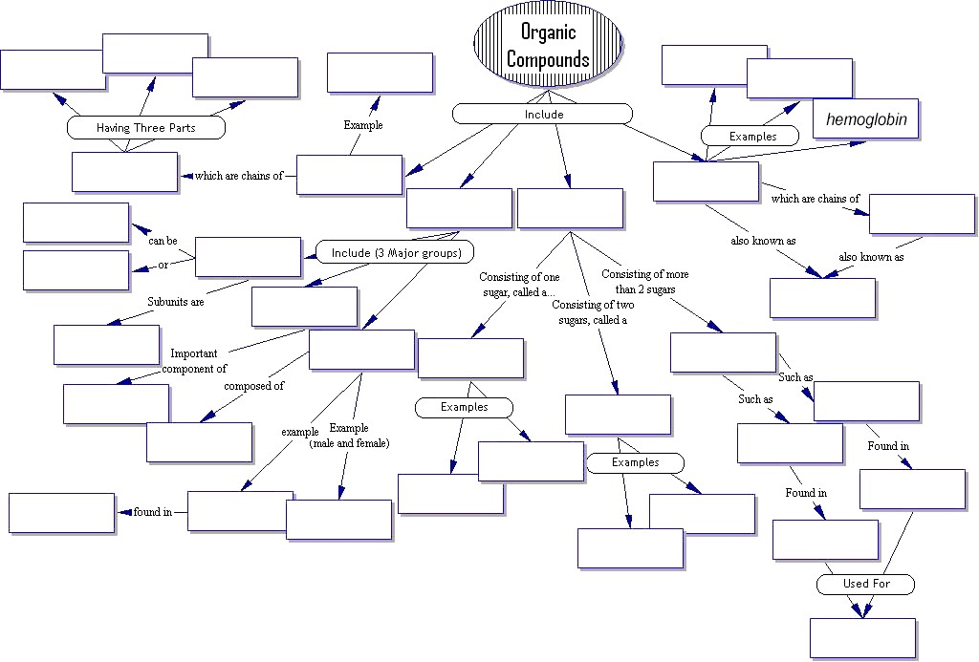
WORD BANK
Amino acids, animals, Carbohydrates, Cell membrane, Cholesterol, DNA, Disaccharide, Egg yolk, Energy storage, Enzymes, Fats, Fatty acid, Fructose, Glucose, Glycogen, Hemoglobin, Hormones, Insulin, Lactose, Lipids, Monosaccharide, Nitrogen Base, Nucleotide, Nucleic Acids, Phosphate Group, Phospholipid, Plants, Polypeptides, Polysaccharides, Proteins, Saturated, Starch, Steroids, Sucrose, Unsaturated, 4 rings of carbon, 5 carbon sugar

