NAME: _________________________________________________________________________________

Pipe Cleaner Babies
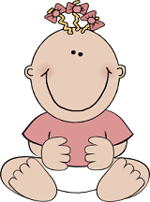
In this activity you will play the role of a parent, your lab partner will play the role of the other parent. You will use chromosome and gene models to create four offspring and determine their genotypes and phenotypes. Then mathematically, you will determine the probability of having offspring with different traits.

How to Use the Model
You will receive a baggie with pipe cleaners and beads. The pipe cleaners represent chromosomes and the beads represent genes located on the chromosomes. In humans, there are 23 pairs of chromosomes and thousands of genes, but for this exercise, we will only focus on a few.
Without opening the bag, notice that you have four white and two colored pipe cleaners. If you have two pink chromosomes, you are to play the role of female (XX). If you have one pink and one blue, you are to play the role of the male (XY).
1. What do the pipe cleaners represent? ___________________________________
2. What do the beads represent? ______________________
3. Humans have ___________ pairs of chromosomes.
4. If you have two pink pipecleaners, you are playing the role of _________________
5. The blue pipecleaner represents the _________ chromosome.

Figure out the parents traits
Remove the chromosomes from the bag, but make sure you do NOT mix up you and your partner's chromosomes. Arrange the chromosomes in order of size, you should have two long white pipecleaners, two shorter pipecleaners, and the two colored pipecleaners.
The white pairs represent HOMOLOGOUS CHROMOSOMES.
The colored pairs represent SEX CHROMOSOMES
Eye Color (longer white pipe cleaners)  Grey bead represents the dominant gene - brown eyes  Blue bead represents the recessive gene - blue eyes  BB = brown eyes | Bb = brown eyes | bb = blue eyes | Hair Color (shorter white pipe cleaners)  The red bead represents the dominant gene- dark hair  The ivory bead represents the recessive gene - blonde hair  DD= dark hair | Dd = dark hair | dd = blonde hair
What color eyes does the mom have ______ What is her genotype? ____  What color eyes does the dad have? _____ What is his genotype? ____ | What color hair does mom have ? _____ What is her genotype? _____  What color hair does dad have? ____ What is his genotype? _____
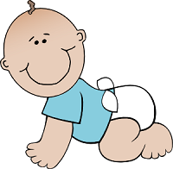
Hemophilia (sex chromosomes, colored pipe cleaners)
The purple bead represents the dominant gene -- normal
The clear bead represents the recessive gene -- hemophiliac
In girls: HH = normal | Hh = normal (carrier) | hh = hemophiliac
In boys: H = normal | h = hemophiliac
What is mom's genotype? _________Is she a carrier? _________
What is dad's genotype? ___________
Why doesn't dad get two alleles for this trait?_____________________

Time to Start Your Family
--The dad places one set of the homologous pairs (ex: that longer set) behind his back, with a chromosome in each hand. The mom picks the hand she wants for the child. Lay this chromosome on the table in front of you and set the other aside.
-- Repeat this procedure for the other homologous pair (ex: shorter set) and for the sex chromosomes. Its should be noted that if the blue chromosome gets chosen from the sex chromosomes, the child in this cross is going to be a boy.
--Now the "mom" places one set of the homologous pairs behind her back and the male chooses.
-- The chromosomes chosen and set on the table in front of you are the genes your first child received.

Determine the Traits of Your First Child
Arrange the chromosomes into homologous pairs and figure out what phenotypes (appearance or trait) the offspring has.
What is the sex of the child? _________
What color eyes does the child have? _______ Genotype?______
What color hair does the child have? _______ Genotype?______
Is the child a hemophiliac? ______ Is the child a carrier for hemophilia? _____

Data Table
Go to the last page and see the data table, the first group is you and your partner. You are going to have 4 children. Repeat the procedure you used to make you first child to make 3 others. Fill out their traits on the table.
When you are finished, you will post your data on the board. Other groups will also post their children's data. Fill out the entire chart will all the parents in the class.
Replace all Chromosome into the correct baggie, make sure you have the right chromosomes in the bag and return.
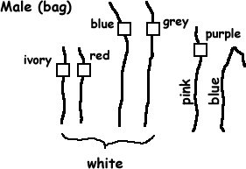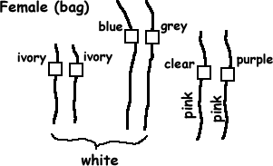\

Analysis - answer on a separate page
1. Create a punnet square for each of the crosses, using your parents. (You'll have a square for hair color, eye color, and hemophilia)
2. Explain why women are carrier's for the disease hemophilia. Why do their sons, but not their daughters get the disease?
3. Describe the difference between how normal traits are inherited and how sex linked traits are inherited.
4. The data table where all the data is combined, shows how many ACTUAL offspring would have each of the traits. The punnet squares (from #1) show the PREDICTED ratios. Compare the actual to predicted ratios for all three traits.
5. Notice on the data table that no female has the disease hemophilia. Explain why.
6. If you knew you were a carrier for hemophilia (or your wife was), would you choose to have children. Explain your reasons.
**Turn in these pages (with both names), the data table, and the answers to analysis (which should have a single name)
 | Eye Color | Hair Color | Sex | Hemophilia | Compile Data
Group 1 |  |  |  |  | Total Number of Babies _____  Total Number of Girls _____  Total Number of Boys _____  # of Babies with Brown Eyes _____  # of Babies with Blue Eyes _____  # of Babies with Dark Hair _____  # of Babies with Blonde Hair _____  # of Girls with Hemophilia _____  # of Boys with Hemophilia _____  Convert your data to percentages. To get the percents, divide the number you have by the total number and x 100.  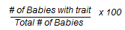  Girls _____  Boys _____  Brown Eyes _____  Blue Eyes _____  Dark Hair _____  Blonde Hair _____  Hemophiliac Girls _____  Hemophiliac Boys _____
Group 2
Group 3
Group 4
Group 5
Group 6
Group 7
Group 8
Group 9
Group 10
Group 11
Group 12

