Organic Chemistry - Reinforcement
Designed for AP Biology
1. Examine each of the monosaccharides below identified as hexoses.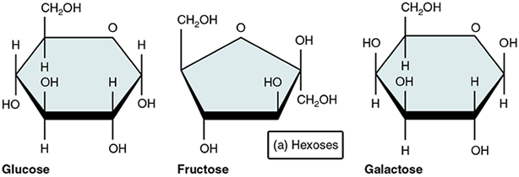
a) What is the molecular formula of glucose? Fructose?
b) What do all of the hexoses have in common? What makes them different?
c) Why are these molecules called hexoses?
2. Two monosaccharides can combine to create ______________________________________
a) Identify the monosaccharide subunits in each molecule.
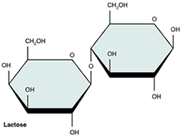
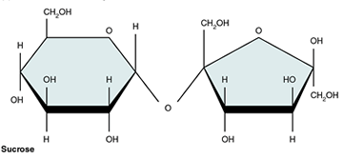
b) Where is sucrose found? Where is lactose found?
3. Compare the structure of ribose to deoxyribose.
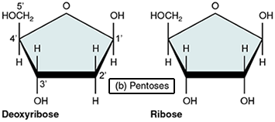
a) In the image of deoxyribose, the carbons have been numbered, number the same carbons in the ribose molecule.
b) Why are these molecules called "pentoses?"
c) How is deoxyribose similar to other monosaccharides?
d) How does ribose differ from deoxyribose?
4. Identify each part of the molecule below.
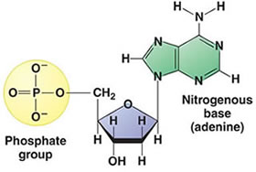
a) Where is this molecule found?
b) What other bases can be substituted for adenine?
c) Is the molecule from DNA or RNA? How do you know?
5. Below is a molecule of ATP. How is it similar to a nucleotide?
