NAME: ____________________________________________________

AP BIOLOGY 2014-15
RESPIRATION AND ANIMAL HOMEOSTASIS TEST

- Metabolism of which of the following molecules results in the greatest net usable energy per gram?

(A) A triglyceride
(B) A tripeptide
(C) An alpha-linked disaccharide
(D) A beta-linked disaccharide

Answer = A

- Cell communication is critical for the function of both unicellular and multicellular eukaryotes. Which of the following is likely true of cell signaling?
        - A. cell signaling uses the highest molecular weight molecules found in living cells
        - B. Cell signaling has largely been replaced by other cell functions in higher mammals.
        - C. Similar cell signaling pathways in diverse eukaryotes are evidence of conserved evolutionary processes.
        - D. Cell signaling functions mainly during early developmental stages.

Answer = C

- In mammals, which of the following substances is produced in a muscle that operates anaerobically?

(A) Acetyl CoA
(B) Citrate
(C) NADPH
(D) Lactate

Answer = D

- Production of ATP occurs in all of the following processes EXCEPT
(A) glycolysis
(B) electron transport system and chemiosmosis
(C) light-dependent reactions of photosynthesis
(D) light-independent reactions of photosynthesis

Answer = D (You would not know this answer as we have not done photosynthesis yet this year)

- Which of the following occurs in both fermentation and aerobic cellular respiration?
(A) Oxygen and carbon dioxide are consumed.
(B) FAD is reduced, driving ATP synthesis.
(C) Proton gradients are produced across membranes.
(D) ATP is synthesized from ADP and inorganic phosphate.
(E) Most of the energy from glucose is released as carbon dioxide.

Answer = NO CORRECT ANSWER IN MY OPINION

- Two nutrient solutions are maintained at the same pH. Actively respiring mitochondria are isolated and placed into each of the two solutions. Oxygen gas is bubbled into one solution. The other solution is depleted of available oxygen. Which of the following best explains why ATP production is greater in the tube with oxygen than in the tube without oxygen?
- The rate of proton pumping across the inner mitochondrial membrane is lower in the sample without oxygen.
- Electron transport is reduced in the absence of a plasma membrane.
- In the absence of oxygen, oxidative phosphorylation produces more ATP than does fermentation.
- In the presence of oxygen, glycolysis produces more ATP than in the absence of oxygen.

Answer = A

7. If you were able to stop the process of cellular respiration after completing electron transport but prior to
chemiosmosis, you would find the pH of a mitochondrion to be at its lowest

(A) on the outer membrane.
(B) on the inner membrane.
(C) in the mitochondrial matrix.
(D) in the intermembrane space.

Answer = D

8. When a stimulus is applied to a receptor in the skin, an action potential is propagated along a neuron to the
brain, where another signal is sent back to the muscle for a response.

Which of the following best describes what occurs when the action potential reaches a chemical synapse at the
end of an axon?
- The action potential jumps from one axon to the next connecting axon.
- The action potential travels through the synapse to the next connecting dendrite.
- The action potential jumps the synapse to the next connecting dendrite.
- The action potential causes a release of neurotransmitters that travel across the synapse.

Answer = D

9. The function of coenzyme A in the citric acid cycle is most like
(A) a limousine driver dropping off a couple at the school prom.
(B) a frog that turns into a prince.
(C) a kid jumping up and down on a trampoline.
(D) throwing a baited hook into a lake and catching a fish.

Answer = A
10. Which of the following diagrams best represents hormones-activated gene expression?

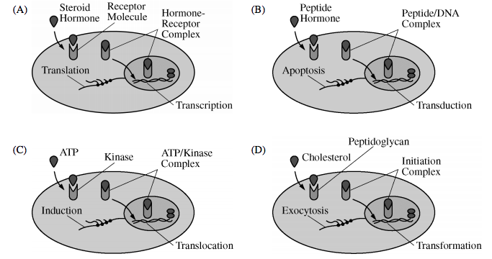
Answer = A

11. Which of the following representations best shows a portion of an axon at rest (before or after an action
potential)?

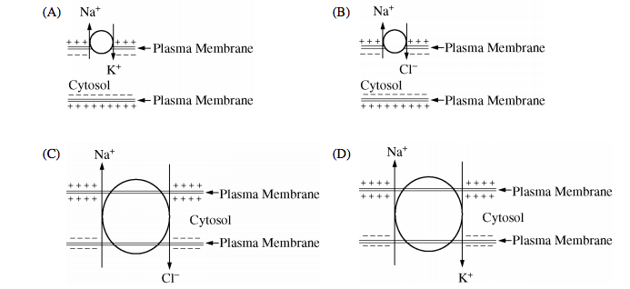
Answer = A

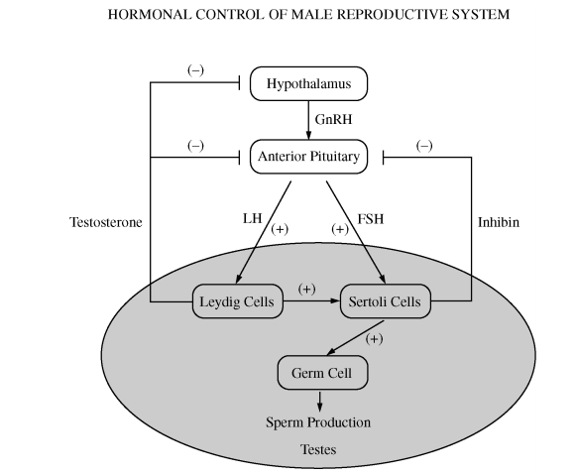

12. Precise regulation of specific hormone levels is required for optimal sperm production in mammals, as
summarized in the figure above. Anabolic-androgenic steroids (AAS) are synthetic variants of testosterone that
are sometimes abused by persons who desire to enhance their athletic performance or alter their physique.
Assuming that AAS function in the same way as naturally occurring testosterone, it is most likely that abuse of
AAS would

- stimulate FSH secretion
- stimulate testosterone production
- stimulate LH secretion
- reduce sperm production

Answer = D

13. During redox reactions,
(A) the loss of electrons from one substance is called reduction.
(B) a substance that gains electrons is said to be oxidized.
(C) electrons are lost from one substance and added to another substance.
(D) protons from one molecule replace the electrons lost from another molecule.

Answer = C

14. A drug is tested in the laboratory and is found to create holes in both mitochondrial membranes. Scientists
suspect that the drug will be harmful to human cells because it will inhibit
(A) the citric acid cycle.
(B) oxidative phosphorylation.
(C) glycolysis.
(D) the citric acid cycle and oxidative phosphorylation.

Answer = B

15. During chemiosmosis,
(A) energy is released as H+ ions move freely across mitochondrial membranes.
(B) ATP is synthesized when H+ ions move through a channel in ATP synthase.
(C) a concentration gradient is generated when large numbers of H+ ions are passively transported from the
matrix of the mitochondrion to the mitochondrion's intermembrane space.
(D) H+ ions serve as the final electron acceptor.

Answer = B

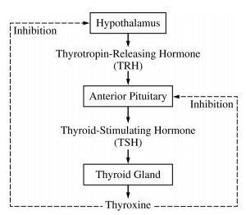
16. The diagram above illustrates feedback control as exerted by the hormone thyroxine. Following surgical
removal of the thyroid gland, the level of TSH in the blood will increase. Which of the following best explains
this increase?
- Residual blood thyroxine, from prior to thyroid gland removal, will bind to cells in the anterior pituitary, signaling more TSH secretion.
- Thyroxine will remain bound to thyroxine receptors on various body cells, and these body cells will secrete additional hormones that stimulate the anterior pituitary to secrete TSH.
- Thyroxine that was stored in the anterior pituitary prior to thyroid gland removal will signal more TSH secretion.
- A decrease in thyroxine levels means a loss of inhibition to the hypothalamus and anterior pituitary, leading to increased TSH secretion.

Answer = D

17. Antidiuretic hormone (ADH) is important in maintaining homeostasis in mammals. ADH is released from the
hypothalamus in response to high tissue osmolarity. In response to ADH, the collecting duct and distal tubule
in the kidney become more permeable to water, which increases water reabsorption into the capillaries. The
amount of hormone released is controlled by a negative feedback loop.

Based on the model presented, which of the following statements expresses the proper relationship between
osmolarity, AHD release, and urine production?
- As tissue osmolarity rises, more ADH is released, causing less water to be excreted as urine.
- As tissue osmolarity rises, less ADH is released causing less water to be excreted as urine.
- As tissue osmolarity rises, more ADH is released, causing more water to be excreted as urine.
- As tissue osmolarity rises, less ADH is released, causing more water to be excreted as urine.

Answer = C

18. Some friends are trying to make wine in their basement. They've added yeast to a sweet grape juice mixture
and have allowed the yeast to grow. After several days they find that sugar levels in the grape juice have
dropped, but there's no alcohol in the mixture. The most likely explanation is that
- the mixture needs more sugar, because yeast need a lot of energy before they can begin to produce
alcohol.
(B) the mixture needs less oxygen, because yeast only produce alcohol in the absence of oxygen.
(C) the mixture needs more oxygen, because yeast need oxygen to break down sugar and get enough energy
to produce alcohol.
(D) the yeast used the alcohol as a carbon source.

Answer = B

19. Information is transmitted through the nervous system when on e neuron signals another neuron. The
structure of neurons enables transmission to proceed quickly and efficiently. Which of the following diagrams
correctly identifies both the structure of neurons and the directions of information flow between neurons?

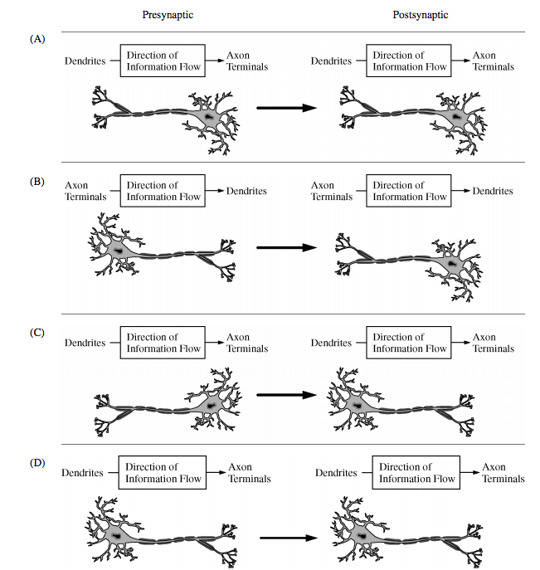

Answer = D

20. The healthy human immune system responds to pathogens with both specific and nonspecific processes of the
following models depicts a nonspecific response?

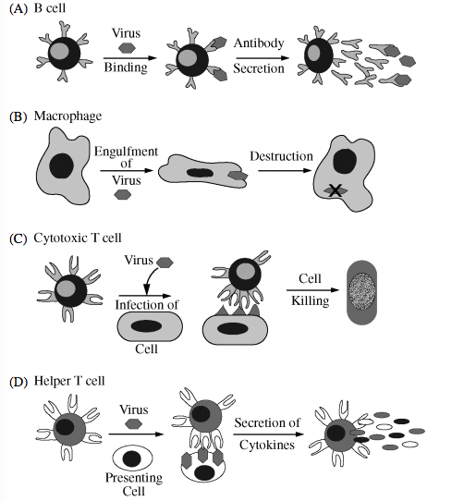
Answer = B

21. When an organism such as a yeast lives by fermentation, it converts the pyruvate from glycolysis into a
different compound, such as alcohol. Why doesn't it secrete the pyruvate directly?
(A) The conversion yields 32 ATP per pyruvate molecule.
(B) The conversion yields one NADH per pyruvate molecule.
(C) The conversion is needed to regenerate the molecules needed for glycolysis.
(D) A buildup of pyruvate in the surrounding environment would be too toxic.

Answer = C

22. Which of the following options lists the sequence of events in the cell-signaling process in the correct
order?
(A) reception, response, signal transduction
(B) signal transduction, reception, response
(C) signal transduction, response, reception
(D) reception, signal transduction, response

Answer = D
23. The major result of the inflammatory response is to
(A) initiate the production of antibodies.
(B) remove contaminating microorganisms and initiate repair of damaged tissues.
(C) initiate cell-mediated immune responses.
(D) initiate the production of killer cells.

Answer = B

24. Which H+ ion has just passed through the inner mitochondrial membrane by diffusion?

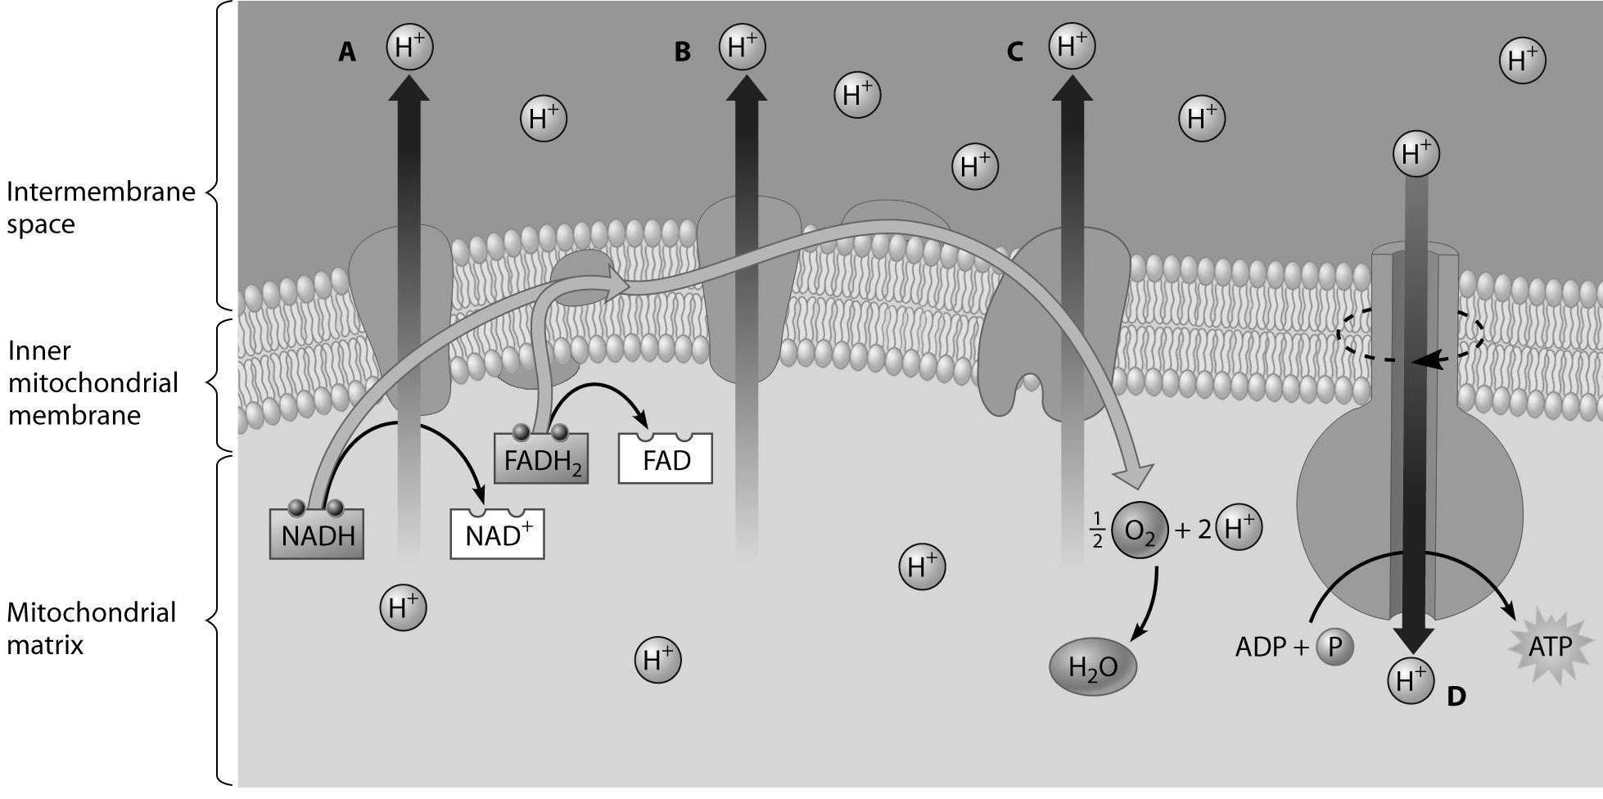

(A) hydrogen ion A
(B) hydrogen ion B
(C) hydrogen ion C
(D) hydrogen ion D

Answer = D

25. Which of the following statements about the humoral immune response is true?
(A) The humoral immune response defends against bacteria and viruses by activating T cells.
(B) The humoral immune response defends primarily against bacteria and viruses present in body fluids.
(C) The humoral immune response plays a major role in protecting the body from cancerous cells.
(D) The humoral immune response is the result of macrophages producing antibodies.

Answer = B

